Azure Web App Service

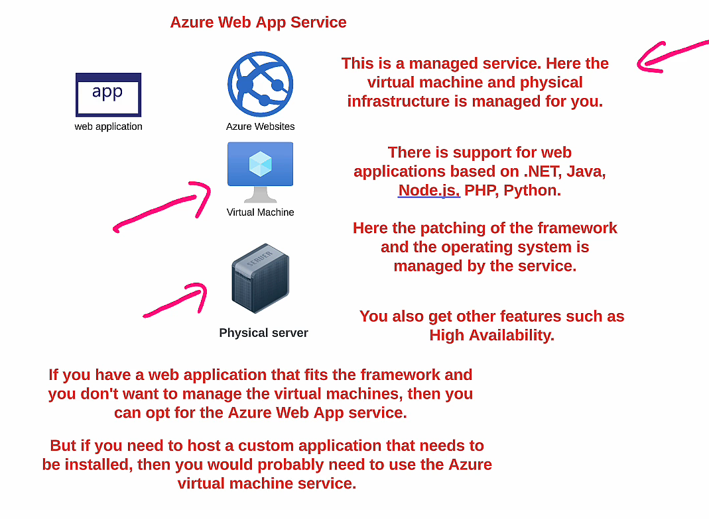

High availability in App service contain

* **Redundancy:**

Having backup systems or components that can take over if the primary fails.

* **Failover:**

The automatic switching from a failed primary component to a backup.

* **Load Balancing:**

Distributing traffic across multiple resources to prevent overload on any single component.

* **Availability Zones:**

Physically separated locations within an Azure region that provide redundancy.

Connect .net application to Azure web app

1. Install App service extension by Microsoft



1. Sign on to azure account in VS code

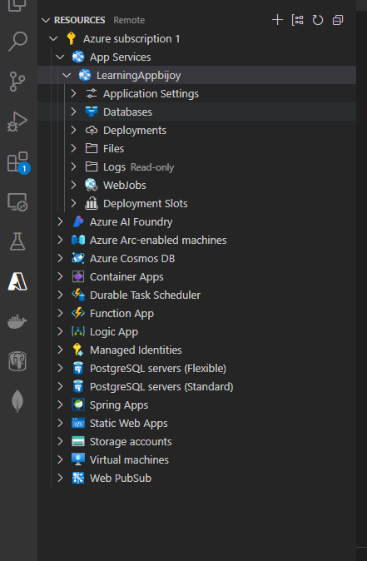

1. In VS code click on project folder where code is published and click “Deploy to Web App”

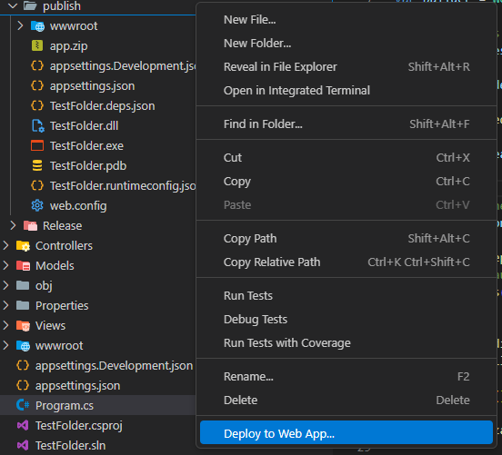

We don’t need to worry about security, OS patching etc if we use Web app

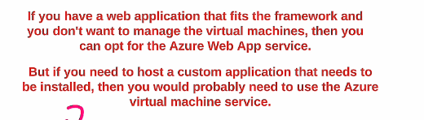

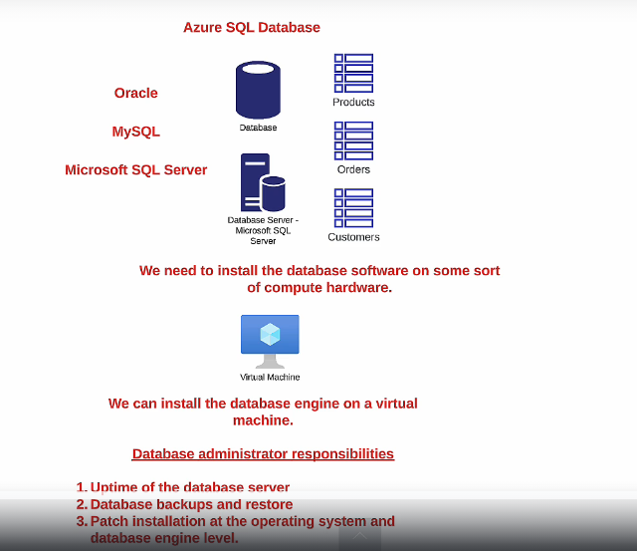

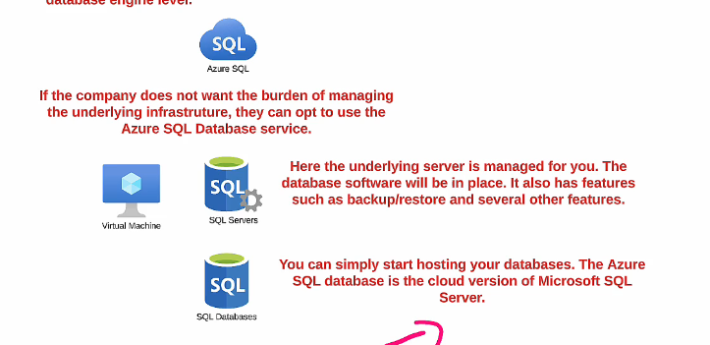

Create Azure SQL Database

Search for SQL Database

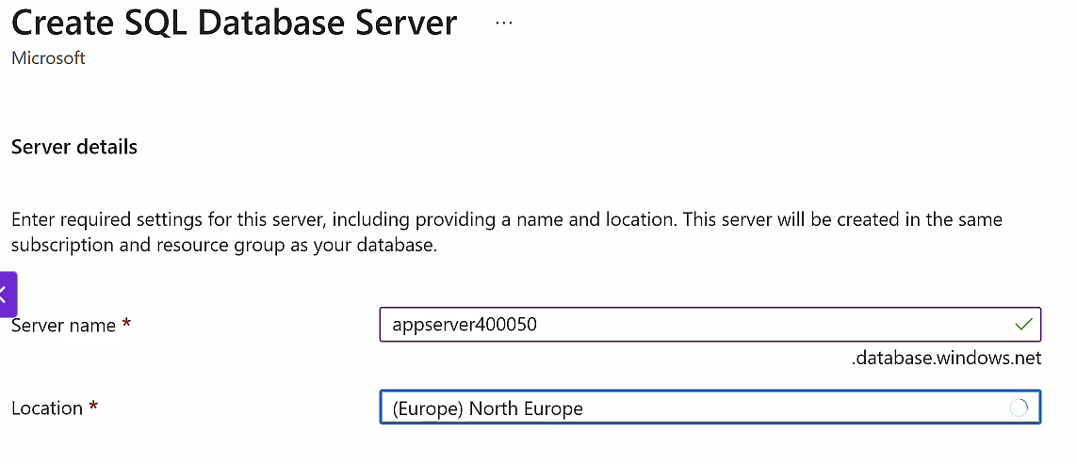

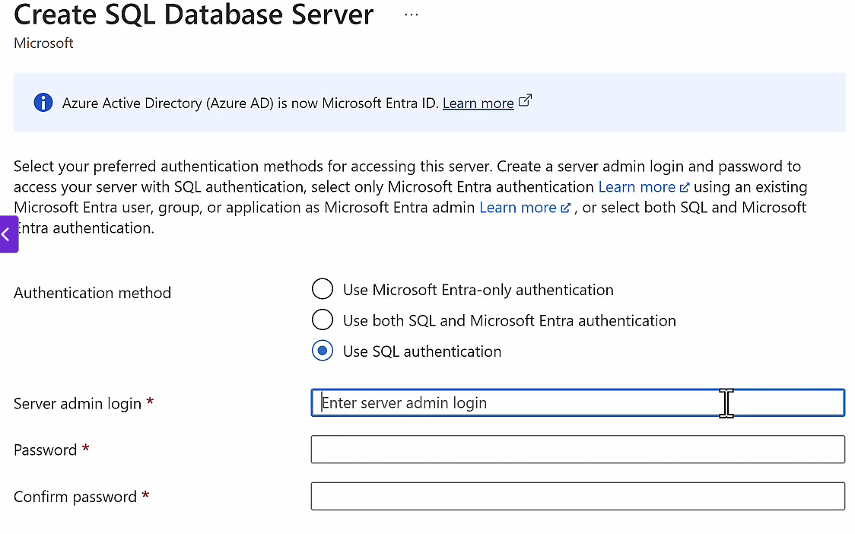

Click Configure and select DTU and then Basic

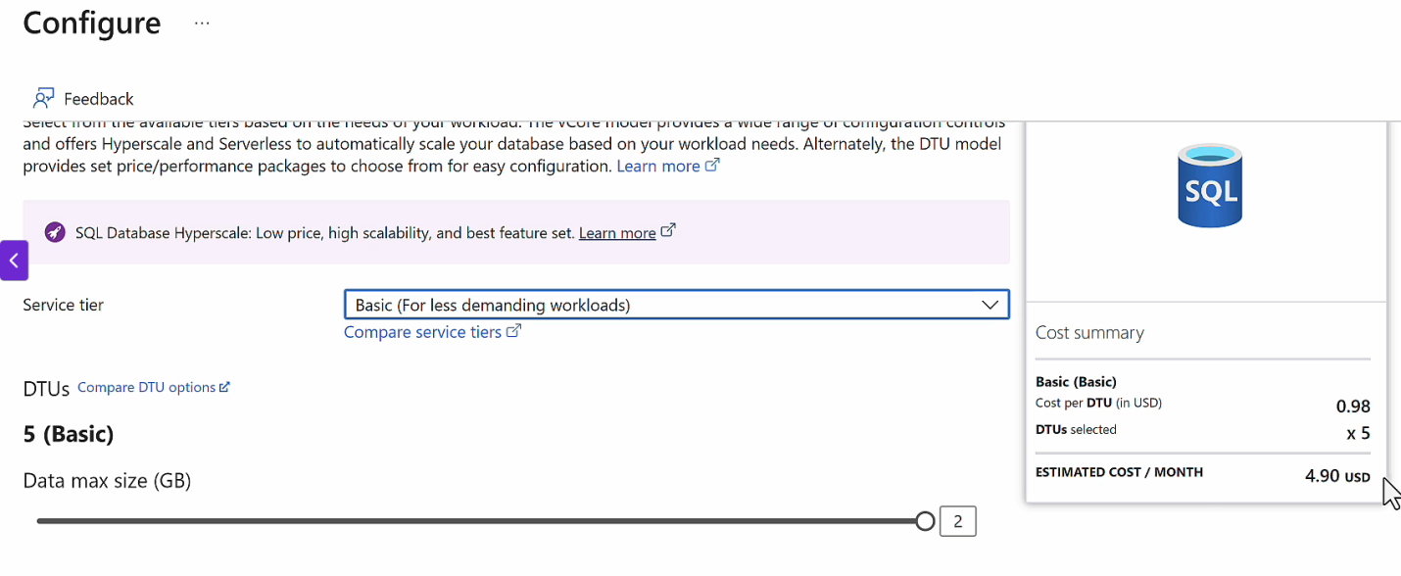

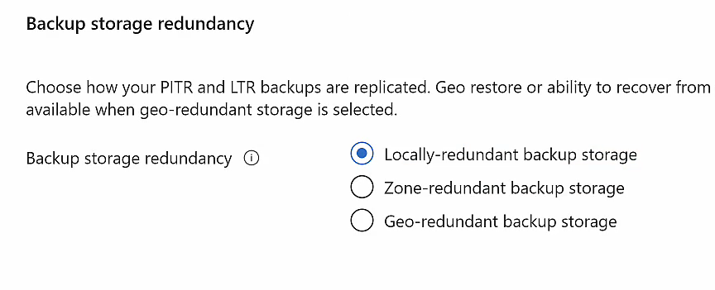

In Networking select following

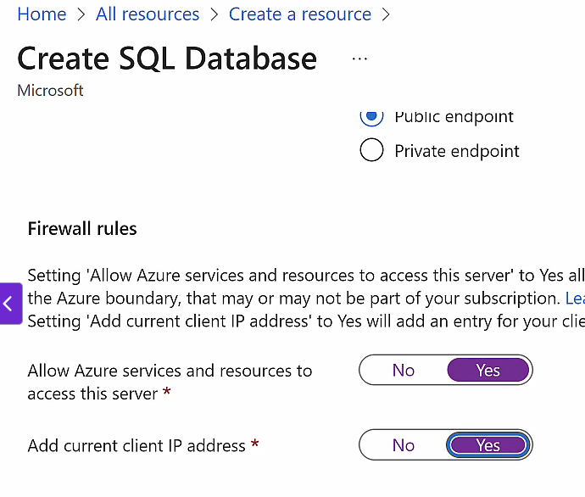

Click next and create.

To use SQL db Go to Resource 🡺 query editor and login

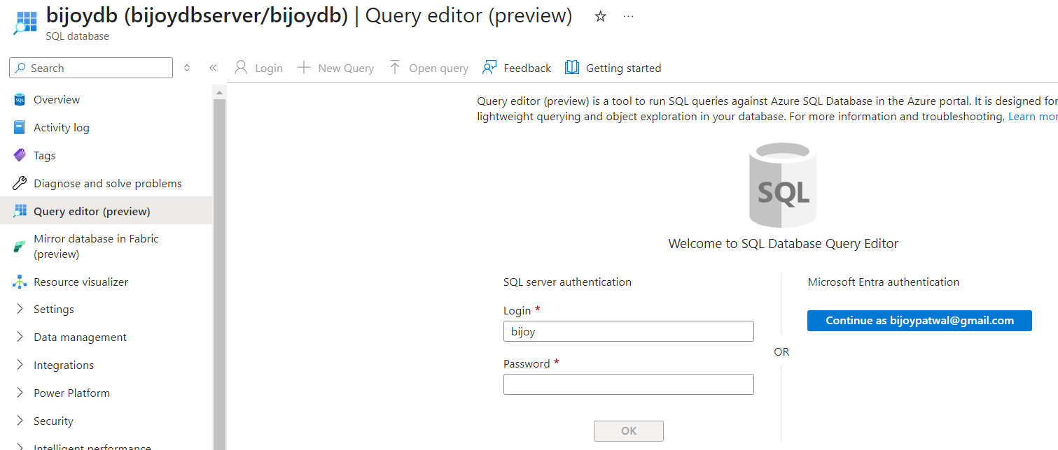

Run following queries for testing

CREATE TABLE Course

(

CourseID int,

CourseName varchar(1000),

Rating numeric(2,1)

);

INSERT INTO Course(CourseID,CourseName,Rating) VALUES(1, 'Docker and Kubernetes',4.5);

INSERT INTO Course(CourseID,CourseName,Rating) VALUES(2,'AZ-204 Azure Developer',4.6);

INSERT INTO Course(CourseID,CourseName,Rating) VALUES(3,'AZ-104 Administrator',4.7);

SELECT * FROM Course;

Connecting with Azure SQL DB

Copy Connection string from “Connection Strings ” section and copy in your application

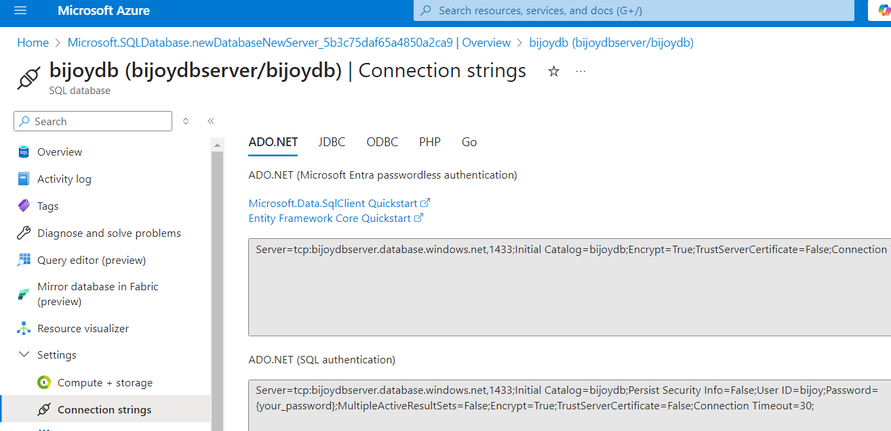

We can now publish app to Azure Web App